TAXON2020 Palynological Index

Dr. Robert L. Ravn, IRF Group, Anchorage, Alaska, USA.

One of the major challenges for palynologists, recognized decades ago, is to keep track of the vast and ever-expanding pile of published information on fossil palynomorphs and their reported occurrences. The Alaska Division of Geological and Geophysical Surveys (DGGS) here presents a new comprehensive index to palynomorph systematic nomenclature and reported occurrences, encompassing all palynomorph types of all geologic ages. Information on approximately 36,000 described species and are cited.

A personal note: This Index is the progeny of an effort started in the mid-1980s as a personal means of keeping track of such information, for the simple practicality of work requirements. It started as a physical index card file, inspired in no small part by a similar effort, then confined to fossil dinoflagellate cysts, by my great friend and colleague, Dr. John E. Williams. The Williams Index (greatly expanded) is now housed at the British Museum of Natural History, and is available for public use there; an effort is presently underway to digitize it.

The file grew rapidly into many thousands of cards, and with the advent of accessible personal computers, it became obvious that getting all that information into searchable electronic files would be greatly desirable. Thus was born the initial form of this data Index, which was titled TAXON, had an easy front-end search utility and menu, and for some years was freely shared with anyone desiring it via computer disks. This early Index depended on the paleocybernetic MS-DOS operating system; when that became functionally extinct with the arrival of more sophisticated operating systems, its utility diminished.

The data files, however, continued to be maintained, and over subsequent years have grown substantially, and continue to do so. It has become highly desirable now to make these files available on-line in a searchable manner, and I am highly grateful to the Alaska DGGS for their interest in putting them up here.

The TAXON2020 Index, as has been noted, was developed for personal needs, and continues to serve that function. It is not to be regarded as a formal academic publication; no new taxonomic names or combinations are proposed, although some are suggested as appropriate in comments. The synonymies presented likewise are from personal preference, and are not intended to be considered “official” in any sense. The structure of the information provided here, however, is designed such that known systematic nomenclatural combinations may be found, in association with reported stratigraphic and geographic occurrences.

STRUCTURE: HOW IT WORKS

As presently constituted, the Index is presented here in the form of PDF files, structured much like a telephone directory (we all remember those, right?). An effort is underway to transform this information into a formal database structure, which will enable more sophisticated searching, but having these “source” files available in PDF form is still highly useful.

The files consist of three major categories: Species files, Genera files, Literature References.

SPECIES FILES

These files constitute the real “core” of the system. They are organized alphabetically by specific epithet, which is the stable part of any binomial taxonomic name. Palynomorphs, like other biological entities, both fossil and extant, are given formal names in the system invented by the great naturalist Linnaeus. This system consists of a generic name and a specific epithet, italicized, e.g., *Homo sapiens* (for us human beings) or *Picea alba* (the white spruce). To be complete, these binomials are followed by the name of the original describer(s) and the date of formal publication. In the case of a typical palynomorph: *Broomea simplex* Cookson and Eisenack 1958. Two similar and rigorous academic codes exist to govern these procedures, the International Code of Botanical Nomenclature (ICBN) and the International Code of Zoological Nomenclature (ICZN); these differ in a few minor respects, but perform the necessary duty of providing a proper structure for the naming process. Most palynological fossils (given the overall name of “palynomorphs”) are considered to be of botanical origin, and are governed nomenclatuirally by the ICBN. One major exception is a group of extinct and problematical fossils called chitinozoans, which are regarded as of animal origin, and therefore governed nomenclaturally by the ICZN.

The formal specific epithet is fixed by publication, and unchangeable (except perhaps for minor corrections in orthography). Owing to that stability of specific epithet, the Species files are alphabetized accordingly. The generic assignment, however, can be changed in publication subsequent to the original, and such assignments often are. Therein lies one major source of nomenclatural proliferation that has made indices like that presented here highly desirable. Homonymies (identical names erected for two or more different species) have often, but not always, been corrected by creation of new replacement names in subsequent publications. In addition, it is common for later workers to propose recognizing that two or more described species may actually represent the same thing, with the one published first having taxonomic priority. The “junior” name equivalents are then often presented as “synonymies”, and that structure is used in the TAXON2020 Species Files, along with cross-references.

The Species files have been maintained as relatively small PDFs, in order to make access and searching simple and fast. At present, this portion of the Index is divided into 79 separate PDF files for which a linked alphabetic index is provided below.

Each individual species in the Index is provided with a unique numerical code, in square brackets (red). The “preferred name” (personal opinion) is given in black, with synonymies listed in green. Below any given nomenclatural citation(s) is a list of reported occurrences (in blue) with authorship, date, and summarized stratigraphic and geographic information. Comments (in purple) are made as appropriate All entries for individual species are linked by that unique numerical code. Names considered to be junior synonyms or homonyms are cross-referenced, as follows:



Directs to:

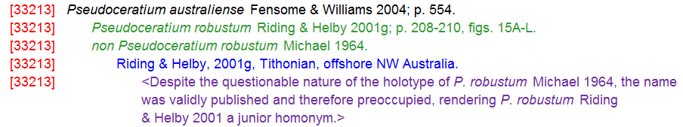

Stratigraphic interpretations are cited, as much as possible, in commonly-applied chronostratigraphic terminology. Information on these names is widely available on geologic column diagrams or elsewhere on-line. Other codes included in parentheses are (cf.) and (aff.), as noted in literature, for forms resembling but not considered identical to the cited species; (T) the genotype species for the genus; (N) the cited reference does not contain an illustration; (R) the cited reference is considered reworked from older strata; (?) the cited reference may be a questionable identification or nomenclatural assignment.

In addition, a gallery of photographic illustrations is being added. A black rectangle at the end of the species entry signifies that an illustration is present in the gallery folder. These are listed by species number and name, e.g.:

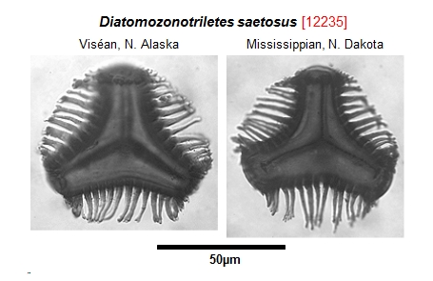

At present, only a small number of photographic illustrations are available, but more will be added, and contributions of copyright-free photographs are most welcome. Any such contributions will be gratefully acknowledged. All should be clearly identified and microscopic measurements should be included, as the intent is to provide a uniform magnification for photographs..

GENERA FILES

These list the generic names, alphabetically, along with authorship and known species combinations:

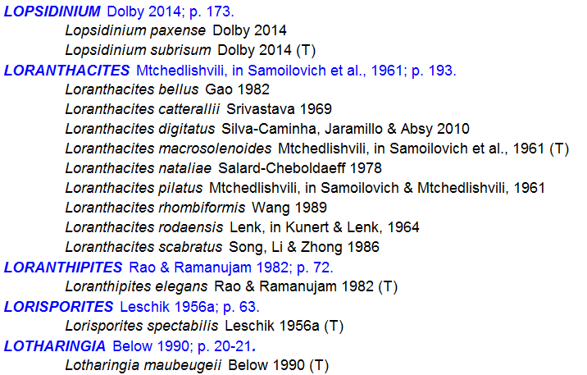

Cross-references, synonymies and comments are displayed similarly to those in the Species files. At present, many of the generic references are in need of authorship/pagination citations; these are being added and most should be greatly expanded by the next update.

REFERENCE FILES

Here are found literature references, alphabetized by surname of senior author, in a form similar to what may be found in any academic publication:

Schiøler, P., & Wilson, G. J. 1995: *Glaphyrosphaera*, a new synonym of *Wilsonisphaera* (Dinophyceae, Gonyaulacales). Taxon, 44, 511–512.

Schiøler, P., & Wilson, G. J. 1998: Dinoflagellate biostratigraphy of the middle Coniacian-lower Campanian (Upper Cretaceous) in south Marlborough, New Zealand. Micropaleontology, 44: 313–349.

Schneebeli-Hermann, E., & Bucher, H. F. R. 2014. Palynostratigraphy at the Permian-Triassic boundary of the Amb section, Salt Range, Pakistan. Palynology, 39: 1-18.

Schneebeli-Hermann, E., Looser, N., Hochuli, P. A., Furrer, H., Reisdorf, A. G., Wetzel, A. & Bernasconi, S. M. 2018. Palynology of Triassic-Jurassic boundary sections in northern Switzerland. Swiss Journal of Geosciences, 111: 99-115.

Scholtz, A. 1985. The palynology of the upper lacustrine sediments of the Arnot Pipe, Banke, Namaqualand. Ann. S. Afr. Mus., 95: 1-109.

Schopf, J. M. 1936a. The paleobotanical significance of plant structure in coal. Illinois State Academy of Science Transactions (1935), 28: 106-110.

Schopf, J. M. 1936b. Spores characteristic of Illinois Coal No. 6. Illinois State Academy of Science Transactions (1935), 28: 173-176.

Schopf, J. M. 1938. Spores from the Herrin (No. 6) Coal bed of Illinois. Illinois Geological Survey Report of Investigations, 50: 1-73.

Both the Genera and Reference files are link-indexed alphabetically, similarly to the Species files. As PDFs, all may be searched using standard utilities for that purpose. Or the entries of interest may be found simply by scrolling through the alphabetized files.

Several other index/database resources exist for fossil palynomorphs of various kinds, and are also highly useful. These include the various editions of the Lentin and Williams indices for dinoflagellate cysts, the most recent edition of which is that of Fensome et al. (2017); with a few exceptions, the systematic practices in that volume are followed here. Of similar format is the acritarch index of Fensome et al. (1990). For generic-level information on spores, pollen and other *incertae sedis* forms, the voluminous card file of Jansonius and Hills (maintained into the mid-1990s) remains invaluable. Also still available and useful is the Palynodata database, maintained into the early 2000s and accessible via the Geological Survey of Canada.

At this time, the Index concentrates on formally-published literature in which photographic illustrations are provided. A great detail of useful information also exists in the form of theses and dissertations which are not considered formal publications, although many are now available free on-line. Some information from a few of these has been included in the Index, and data from others of those freely-available works will be entered in the future as the Index is updated. New taxonomic names or combinations proposed in these unpublished works, however, are invalid by rules of the ICBN and the creation of names in such works should be discouraged.

The TAXON2020 Index remains a work in progress, and will ever be so. As noted, it is not to be considered “official”, nor can it ever be considered “complete”. It is intended as a guide to basic information, and users are urged to consult original publications whenever possible for greater detail. I have been very fortunate over many years to have had access to a wide range of literature, but many citations remain incomplete, where the original published material has not been available. Much older literature has become essentially unavailable in recent years, and represents a significant problem for further research in the field, and by no means are all important journals containing relevant information available on-line. Accordingly, correction of any such omissions would be most desirable, and contributions of relevant literature (especially for older material) would be greatly appreciated. As the current intent is to update the Index periodically, such contributions will be publicly acknowledged. Likewise, comments and suggestions are also welcome.

Robert L.Ravn